|  |  |  |  |  |  |
| --- | --- | --- | --- | --- | --- |
| Date | December 6, 2022 | | | Tester Name | Syed Shahabuddin |
| Environment | Penfax - Test | | | Login used |  |
| Operating System | Windows | Version: | Update: | | |
| Software Used | Edge | Version: | Update: | | |
| Select Software | Version: | Update: | | |
| Release version | 22.4.1 | | | | |
| Title | 26.01 | | | | |
| Test Type | Regression | | | | |
| Test Scenario | Receiving Scheduled Monthly payment, and birthdate on the same day (invested in PEPP steps) | | | | |
|  |  | | | | |
| Expected Results | Both the scheduled withdrawal, the interfund and the DAI change will all process on the same day. The funds withdrawal will still be pro-rated between steps and the specialty fund. | | | | |
| Pass/Fail | Pass | | | JIRA# | N/A |

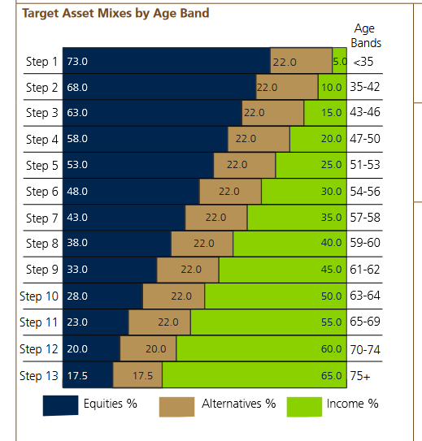

To find members, I went to last month’s payroll (batches/plan production) then searched payment batch type monthly, and found PEPP.

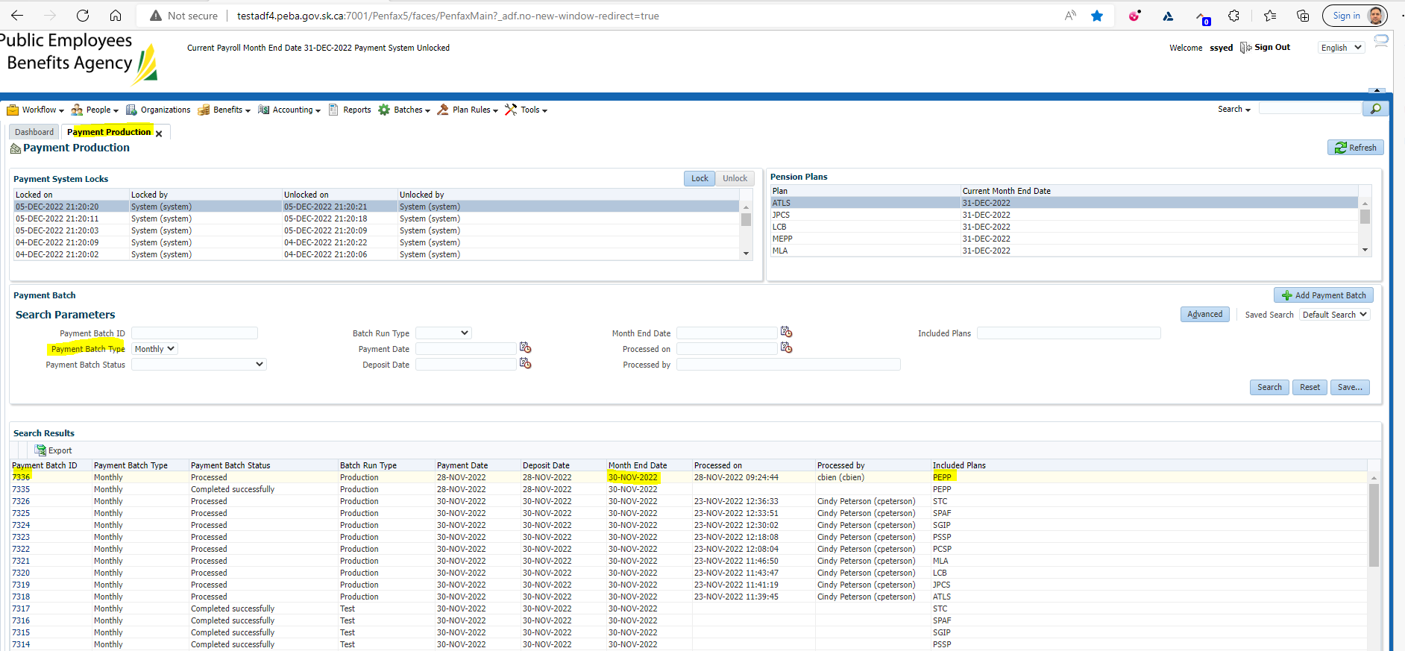

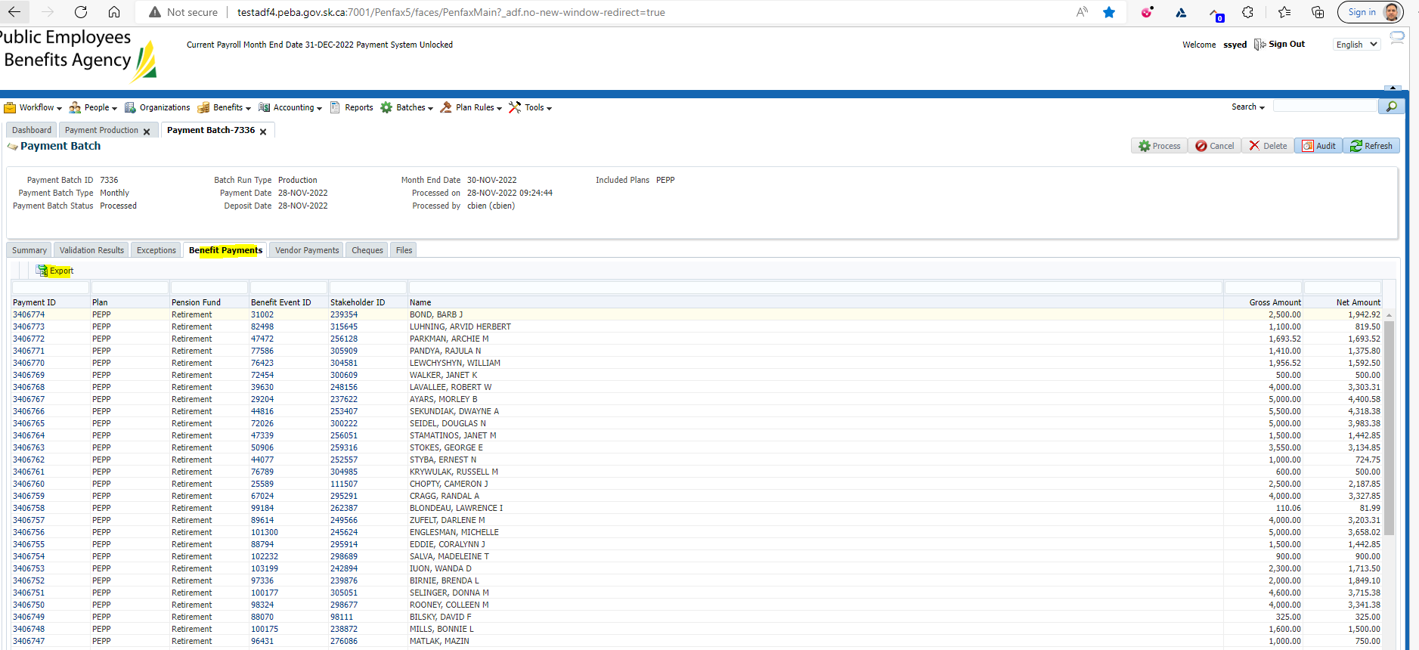

Then I went through the members to find the scenario’s I’m looking for (most are in balanced fund – boo)

Stakeholder 247888 (updated on PlaNet) – Birthdate changed to Sept 23, 1957

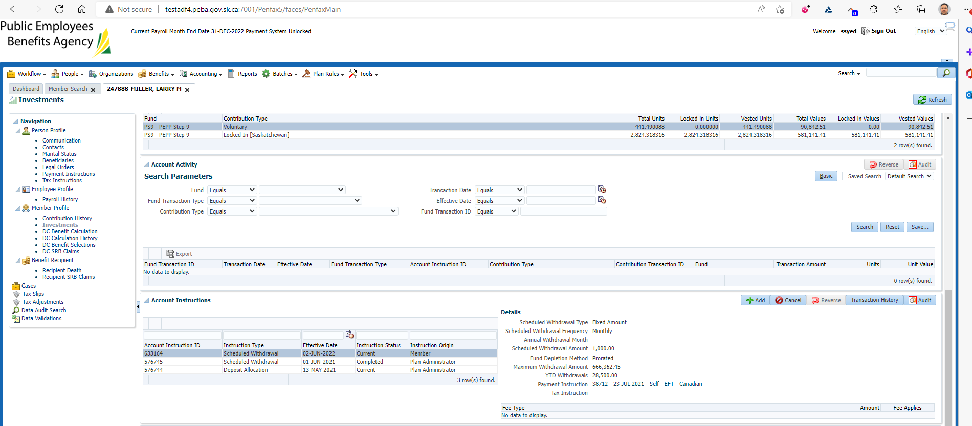

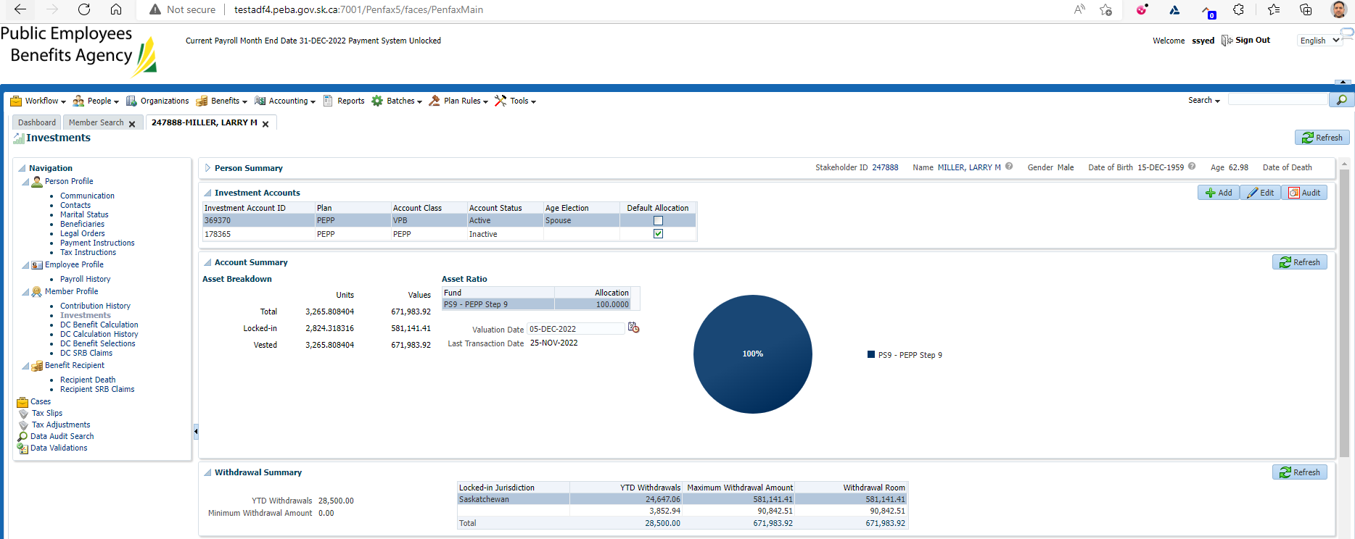

Lifecycle pending – Dec 7th (day running payroll)

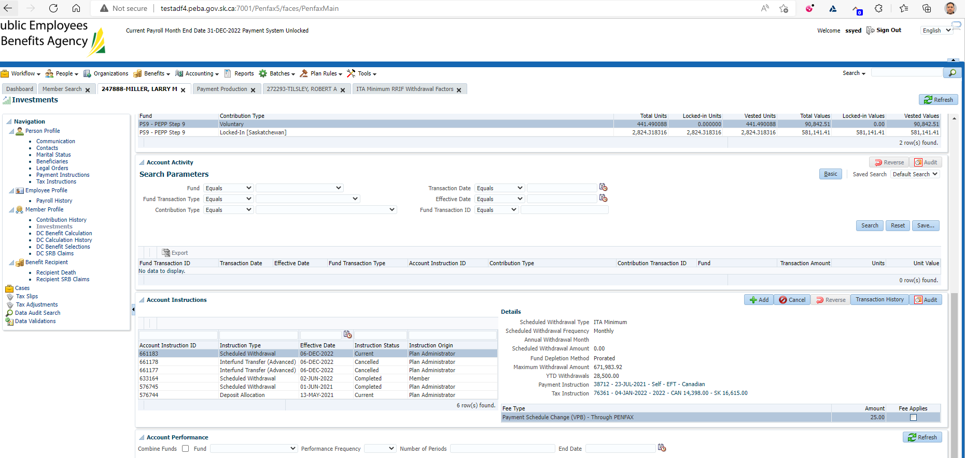

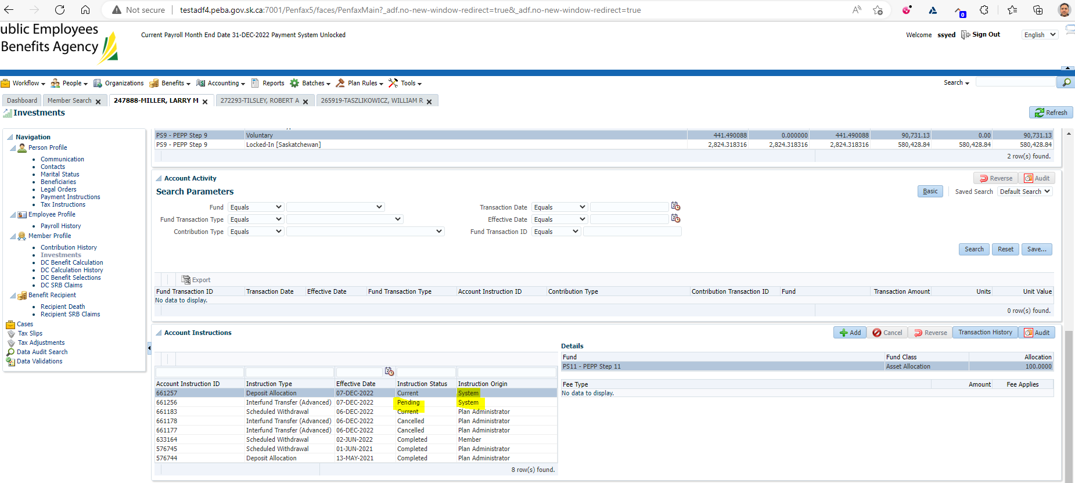

Next day:

Money is in step 11:

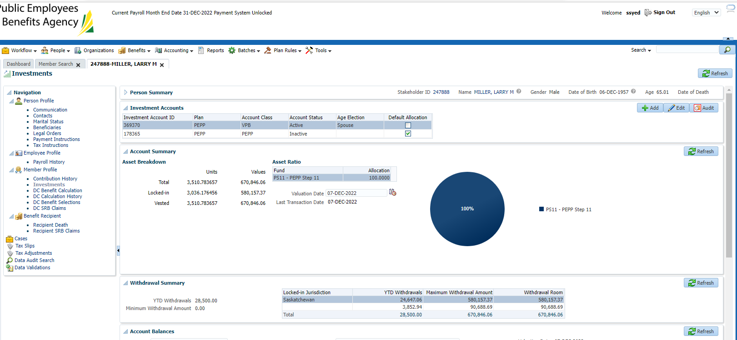

Stakeholder 272293 – ITA minimum monthly, birthdate changed to Sept 24, 1948

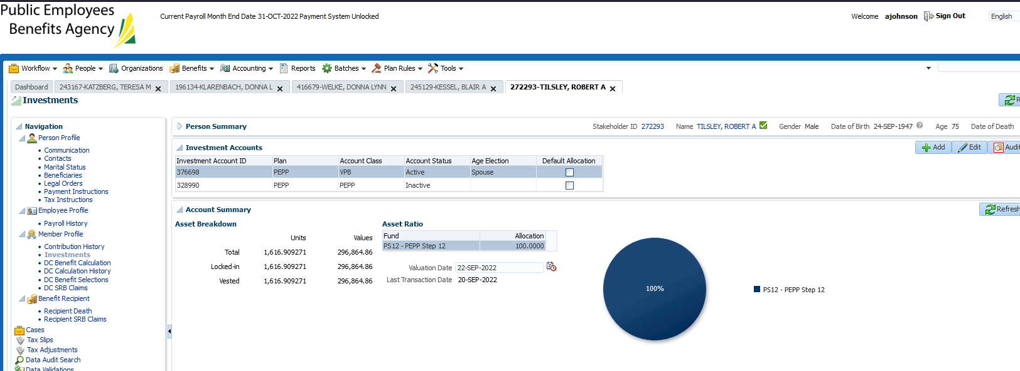

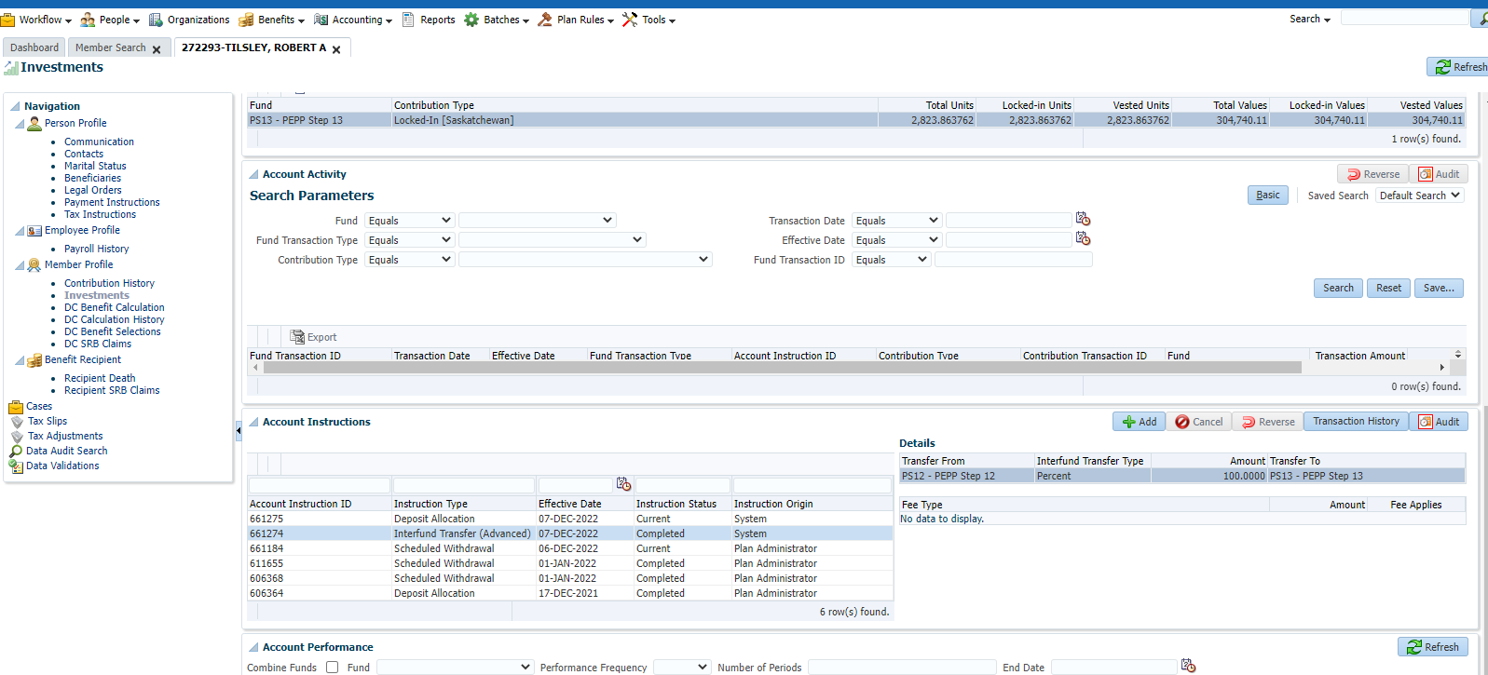

Dec 7, DC lifecycle is pending:

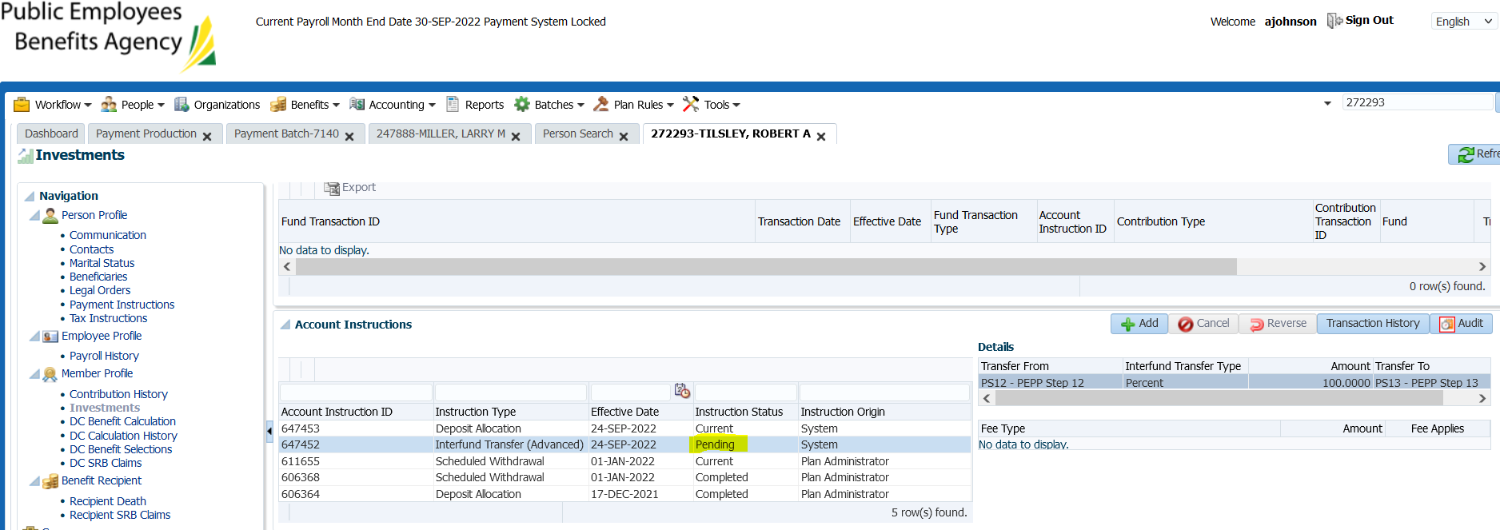

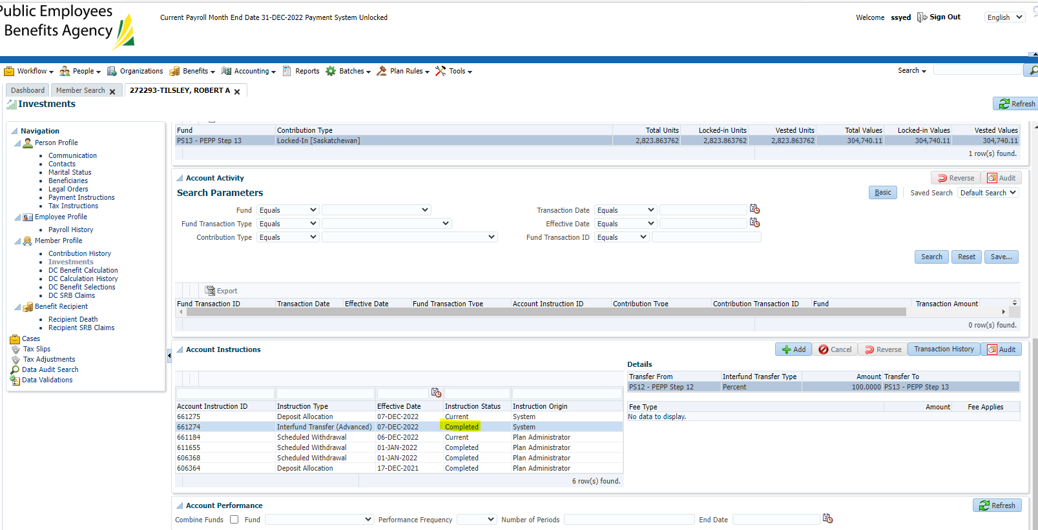

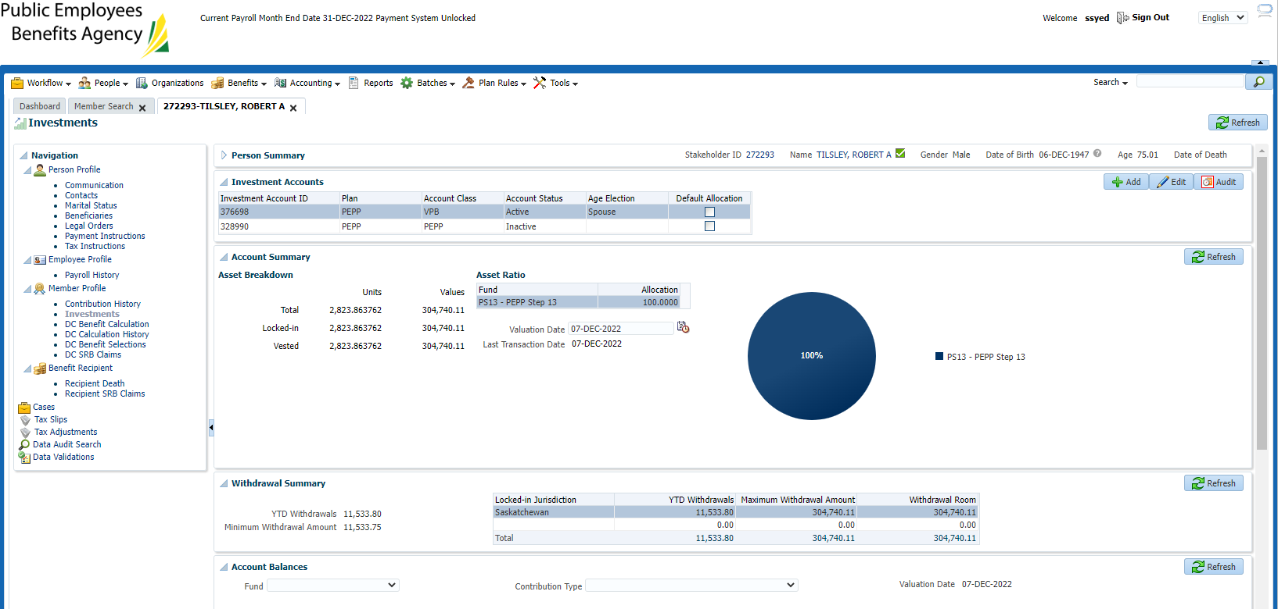

SID: 265919

-confirming that there is a pending interfund tomorrow

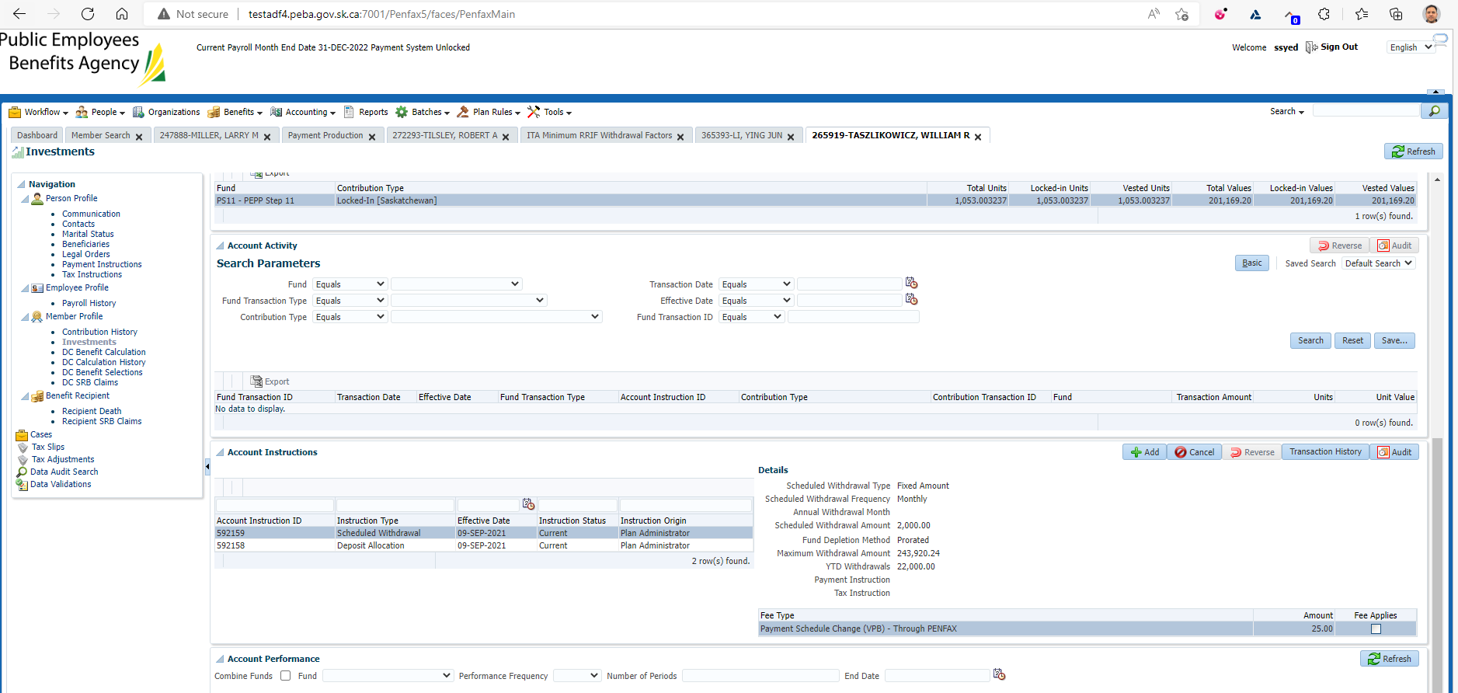

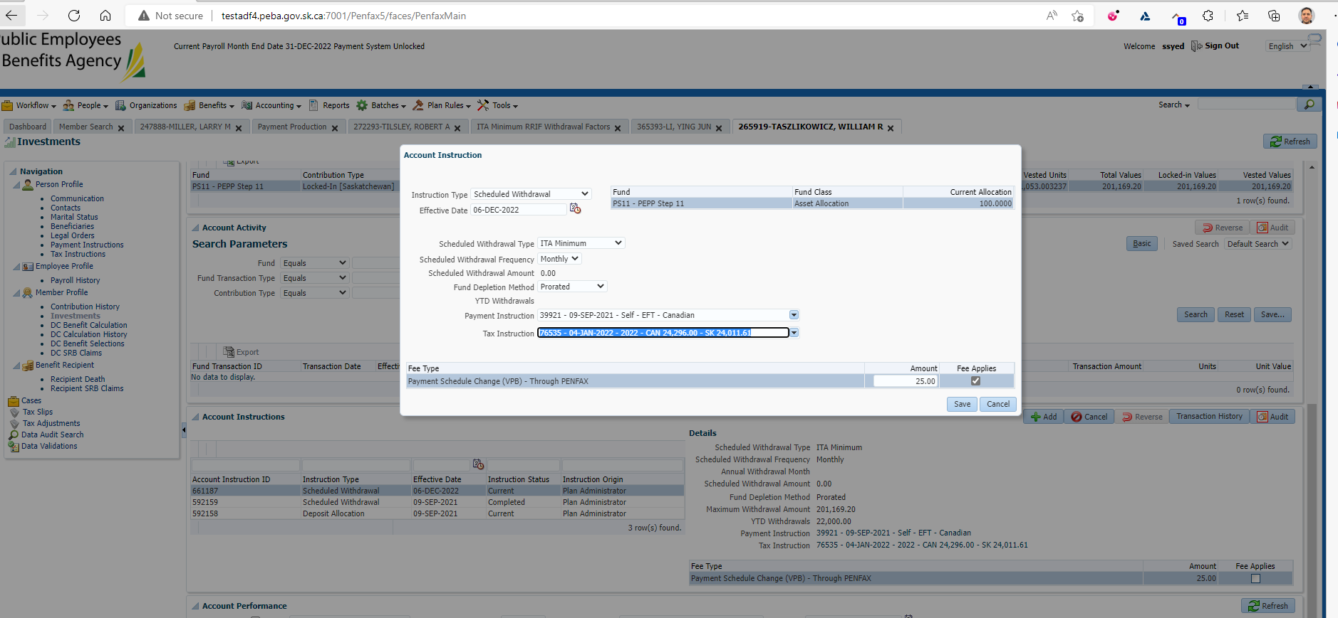

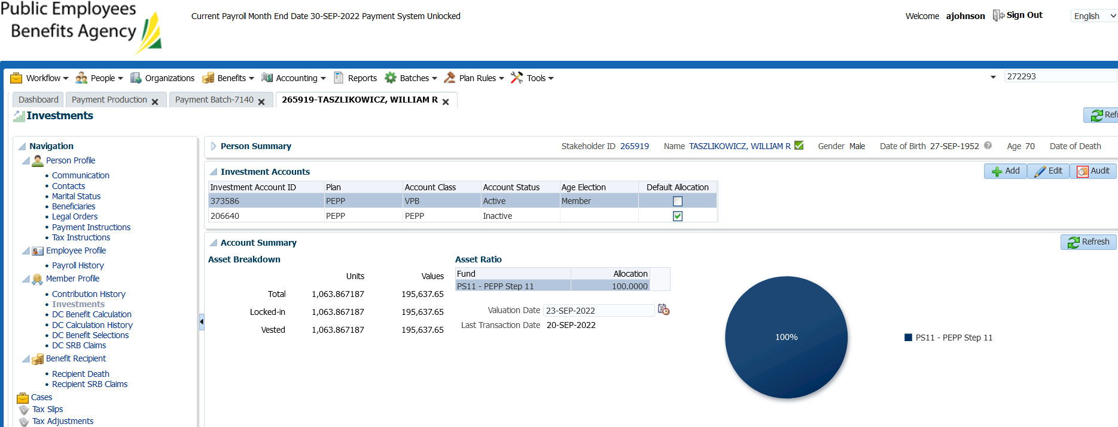

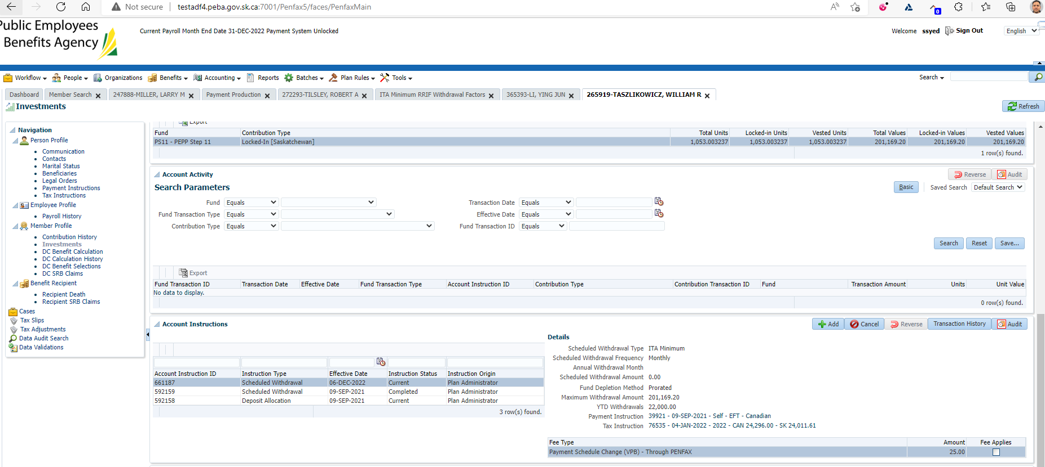

Waiting for payroll to run

